Experiment No.13. Demonstrate the use of Fuzzy C-Means Clustering
AIM: To demonstrate the use of Fuzzy C-Means Clustering using cluster dataset
Requirement: IDE Python , Libraries numpy,pandas , matplotlib.pyplot ,skfuzzy, scikitlearn and cluster dataset
Procedure:
step 1: Import Required Libraries
Step 2: Load the Dataset
Step 3: Standardize the Data
Step 4: Prepare Data for FCM( Transpose the dataset so that its shape becomes features x samples )
Step 5: Apply Fuzzy C-Means Algorithm
Step 6: Convert Fuzzy Membership to Hard Labels
Step 7: Evaluate Clustering Performance
Step 8: Test with a New Sample
#CODE
import numpy as np
import pandas as pd
import matplotlib.pyplot as plt
import skfuzzy as fuzz
from sklearn.preprocessing import StandardScaler
from sklearn.datasets import load_iris
#Load the dataset
iris=load_iris()
df=pd.DataFrame(data=iris.data,columns=iris.feature_names)
X = df.values
# Standardize
scaler = StandardScaler()
X_scaled = scaler.fit_transform(X)
# Transpose for skfuzzy (it expects features x samples)
data = X_scaled.T
#Apply Fuzzy C-Means
n_clusters = 3 # for iris, usually 3 clusters
m = 2.0 # fuzziness parameter
cntr, u, u0, d, jm, p, fpc = fuzz.cluster.cmeans(data=data,c=n_clusters, m=m,error=0.005,maxiter=1000, init=None)
print("Cluster Centers:\n", cntr)
print("\nFuzzy Partition Coefficient (FPC):", fpc)
#Hard cluster assignment (most probable cluster)
cluster_membership = np.argmax(u, axis=0)
print("\nCluster labels:\n", cluster_membership)
#Visualize – first two features
plt.figure(figsize=(7,6))
for j in range(n_clusters):
plt.scatter( X_scaled[cluster_membership == j, 0], X_scaled[cluster_membership == j, 1],
label=f"Cluster {j}" )
# Plot centers
plt.scatter(cntr[:, 0], cntr[:, 1], marker='X', s=200, c='black', label="Centers")
plt.xlabel("Feature 1 (scaled)")
plt.ylabel("Feature 2 (scaled)")
plt.title("Fuzzy C-Means Clustering (Iris Dataset)")
plt.legend()
plt.grid(True)
plt.show()
Output:
Cluster Centers:
[[-1.00488122 0.84621008 -1.28464694 -1.23864555]
[ 1.06990757 0.03775715 0.97058846 1.03032312]
[-0.0374515 -0.81770913 0.32355061 0.23277762]]

Fuzzy Partition Coefficient (FPC): 0.7065166800833028

Cluster labels:
[0 0 0 0 0 0 0 0 0 0 0 0 0 0 0 0 0 0 0 0 0 0 0 0 0 0 0 0 0 0 0 0 0 0 0 0 0
0 0 0 0 0 0 0 0 0 0 0 0 0 1 1 1 2 2 2 1 2 2 2 2 2 2 2 2 1 2 2 2 2 1 2 2 2
2 1 1 1 2 2 2 2 2 2 2 1 1 2 2 2 2 2 2 2 2 2 2 2 2 2 1 2 1 1 1 1 2 1 1 1 1
1 1 2 1 1 1 1 1 2 1 2 1 2 1 1 2 1 1 1 1 1 1 2 2 1 1 1 2 1 1 1 2 1 1 1 2 1
1 2]
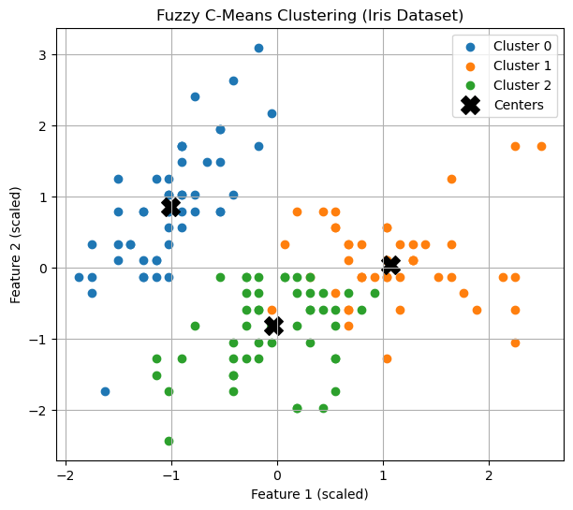

Experiment No.14. Demonstrate the use of Expectation Maximization based clustering algorithm
AIM : To demonstrate the use of Expectation Maximization based clustering algorithm using iris clustering dataset
Requirement: IDE Python , Libraries numpy, pandas , matplotlib.pyplot , scikitlearn and cluster dataset
Theory/Procedure:
1. Load the Iris dataset
2. Standardize the features
3. Apply Gaussian Mixture Model (GMM)
4. Evaluate Clustering Performance
5. Reduce dimensions using PCA for visualization
6. Scatter Plot for Cluster Visualization
# CODE
import numpy as np
import pandas as pd
import matplotlib.pyplot as plt
from sklearn.mixture import GaussianMixture
from sklearn.preprocessing import StandardScaler
from sklearn.decomposition import PCA
from sklearn.metrics import accuracy_score, adjusted_rand_score
from sklearn.datasets import load_iris
# Step 1: Load the Iris dataset
iris = load_iris()
X = iris.data
true_labels = iris.target # Actual class labels for comparison
# Step 2: Standardize the features
scaler = StandardScaler()
X_scaled = scaler.fit_transform(X)

# Step 3: Apply Gaussian Mixture Model (GMM)
num_clusters = 3 # We know Iris has 3 species
gmm = GaussianMixture(n_components=num_clusters, covariance_type='full', random_state=42)
gmm.fit(X_scaled)
predicted_labels = gmm.predict(X_scaled)
# Step 4: Evaluate Clustering Performance
ari_score = adjusted_rand_score(true_labels, predicted_labels)
print(f"Adjusted Rand Index (ARI): {ari_score:.4f}")
# Step 5: Reduce dimensions using PCA for visualization
pca = PCA(n_components=2)
X_pca = pca.fit_transform(X_scaled)
# Step 6: Scatter Plot for Cluster Visualization
plt.figure(figsize=(8, 4))
plt.subplot(1, 2, 1)
plt.scatter(X_pca[:, 0], X_pca[:, 1], c=true_labels, cmap='viridis', edgecolors='k', s=100)
plt.xlabel("PCA Component 1")
plt.ylabel("PCA Component 2")
plt.title("Actual Classes (Iris Dataset)")
plt.subplot(1, 2, 2)
plt.xlabel("PCA Component 1")
plt.ylabel("PCA Component 2")
plt.scatter(X_pca[:, 0], X_pca[:, 1], c=predicted_labels, cmap='coolwarm', edgecolors='k', s=100)
plt.xlabel("PCA Component 1")
plt.ylabel("PCA Component 2")
plt.title("EM-based Clustering using GMM")
plt.tight_layout()
plt.show()
OUTPUT:
Adjusted Rand Index (ARI): 0.9039
